Rationale:
“Handwriting is a tool that has to work. It must be comfortable, fast and legible.” (Angela Webb, Chair, National Handwriting Association)
A consistently high standard of presentation and handwriting is promoted across the whole school. For children and teachers this aims to foster a sense of pride and respect in their work. Self-esteem is raised when children are able to communicate meaning accurately.
We adhere to The British Dyslexia Association’s recommendation that children learn the continuous cursive style.
Handwriting across the school:
- Children in KS1 will write with pencils and children in KS2 can write in blue or black pen if they choose to.
- There will be no lead in to letters when not joining (unless in KS2 and already taught to do this in KS1)
- Children are encouraged to maintain a correct posture and pencil grip
- Handwriting is discretely taught daily in the Foundation Stage and KS1. In KS2 children should be subject to daily practice and intervention if necessary.
- We use the Unlocking Letters & Sounds Handwriting programme although staff can supplement this with other handwriting tools using their professional judgement
- All letters are joined except x
- Opportunities for linking handwriting to phonics and spelling are used
- Handwriting interventions are given to those children whose letter formation, joining or speed require improvement
Teaching and Learning:
We follow the Unlocking Letters and Sounds handwriting programme
- Displays around the school and classroom should model clear joined handwriting as well as other fonts
- Teachers model cursive script on IWB, whiteboards, flip charts etc
- When marking or writing comments, members of staff use cursive handwriting as appropriate
- Older children joining the school, will not be expected to adopt the cursive joined style if they already have a fluent, legible handwriting style
- Bubble Writing is used across KS2 as intervention or whole class along with specialised handwriting books

Provision for left-handed children
Where possible, left-handed children should sit on the left side of right-handed children, so their elbows don’t bump and knock each other. They are encouraged to find a comfortable orientation for their paper, usually slightly to the left centre of their body.
Inclusion:
These expectations apply to the vast majority of children in our Federation. Occasionally a decision will be made to personalise expectations for a child who has such specific needs that these expectations could be a barrier to their progress (e.g. a child with physical difficulties writing). Difficulties are addressed through appropriate interventions or specific equipment. The SENDCo will provide resources for those who have difficulty with fine motor skills – pencil grips, fine motor control programmes and referrals where necessary.
Monitoring:
Presentation is monitored by the English Leads and Senior Leadership Team on a regular basis through work scrutiny, lesson observations and pupil interviews. Feedback will be shared with the class teacher and at Leadership meetings. This will ensure that the policy leads to good practice.
Interventions available:
- ‘Bubble’ writing
- South Warwickshire Intervention & Letter Formation
- Nelson Handwriting (Bev’s office)

Year Group | Handwriting Scheme
Reception / EYFS | Daily lessons  Unlocking Letters and Sounds phonics/handwriting scheme  Learn to write letters as children learn sounds by phases – s,a,t,p,i,n etc.  Print letters (no lead in stroke)  Letter rhymes used to remember formation
Year 1 | Daily lessons  Pre-cursive (each letter formed with an exit stroke)  Unlocking Letters & Sounds (no lead in stroke)
Year 2 | Daily lessons  Pre-cursive leading onto joined towards end of year (no lead in stroke)  Unlocking Letters & Sounds
Year 3 & 4 | 3 times weekly lessons  Daily practise  Cursive joined using Twinkl programme / Unlocking Letters & Sounds
Year 5 & 6 | 3 times weekly lesson/practise (as needed)  Cursive joined using Twinkl programme / Unlocking Letters & Sounds

Handwriting resources:
- https://rebuckedu.wordpress.com/2020/04/14/handwriting-an-8-week-fix-it/
- https://www.unlockinglettersandsounds.com/
- https://www.ictgames.com/mobilePage/writingRepeater/index.html
- https://edu-tools.github.io/
- https://www.unlockinglettersandsounds.co.uk/institute/teacher/courseview/2/view

Unlocking Letters and Sounds Spelling Scheme
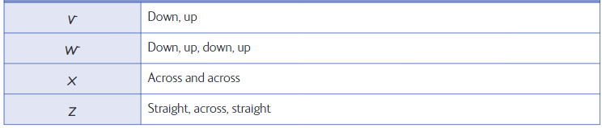  Zigzag Letters | Down Letters  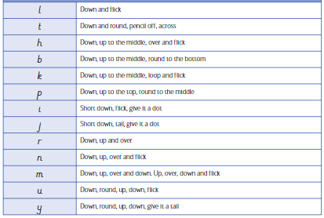
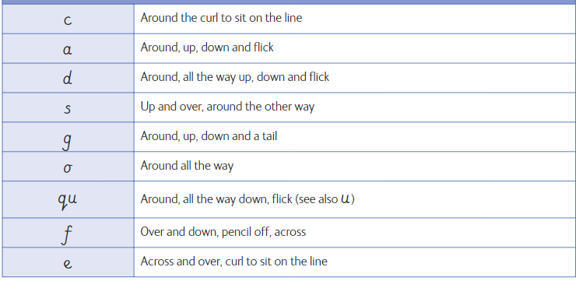
Curly Letters



