Brain Speed Calculation

Materials: Paper response sheet, Tailors tape measure, pen/pencil, Laptop with Brainspeed excel programme, computer logged in to:

http://faculty.washington.edu/chudler/java/stopl.html

Method: Use the tape measure. Place one end at the midline on top of the head and come in front of the ear, down the neck, along the shoulder and all the way to the tip of the index finger. You need three hands to do this so have the child hold the tape in place on the top of their head and then use one hand to hold the tape at the neck/shoulder join and the other to take it to the end of the index finger.
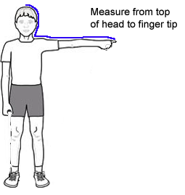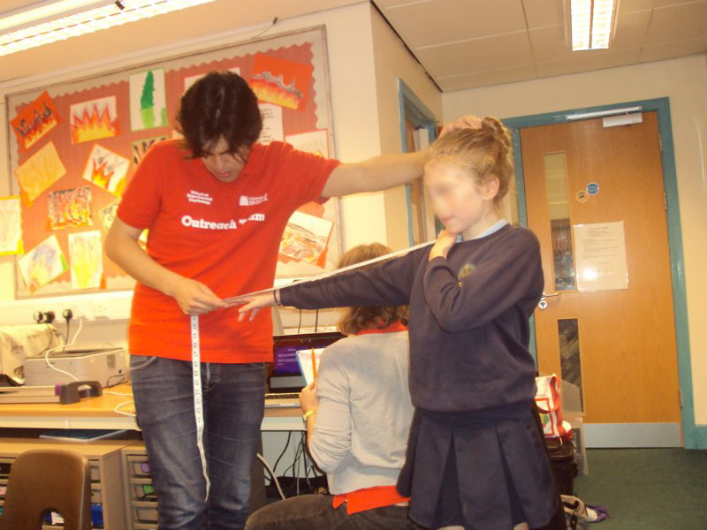

Record this distance in metres (e.g., 0.98) on the response sheet along with the subjects name. Then open the webpage and the subject has 5 attempts to record a response time to the green light. The programme will give the individual times and the average time in seconds (e.g., 0.224). However this can be distorted by one poor response. So select the fastest time (smallest number). It is easy to cheat on this task by continually pressing the mouse key so any time below 160ms can be eliminated, as this is not possible!

Enter the fastest time (smallest number) on the response sheet.

Using the Macintosh laptop open the excel file called Brainspeednew.xlsx and input the average response time (in seconds = the website will give it as milliseconds so need to add 0. in front of the lowest time) and the distance (from head to finger in metres i.e., 1.12). The programme will present speed in Km/h and M/h. Use Km/h as this is a larger number!

Children might want to compare their performance with the teacher or a parent. Note: adult brains are fully developed and this includes a substance called myelin which is used to insulate the axons in the brain conducting the signal. This means that adult signals travel more efficiently and quickly – so this is one where mum and dad or the schools staff should win. Myelination is completed between 20 and 30 years of age. It is important children understand this and that whatever speed they record will get faster as they get older.

Response sheet for Brain Speed

Name | Distance (metres)  93cms = 0.93 metres | Time (seconds) | Speed (KM/h) | What Animal?

Animal Running Speeds for Comparison (we often issue stickers for these in the classroom). Most children will record speeds of cockroach, housefly or mouse. Most adults will be in the chicken to squirrel band.

KMH | Animal Running/Flying Speeds
0.2 | The top speed of a garden snail
0.3 | The top speed of a Galapagos tortoise
1.5 | The top speed of a spider
5 | The top speed of a cockroach
8 | The top speed of a housefly
13 | The top speed of a mouse
14.5 | The top speed of a chicken
17.5 | The top speed of a pig
19 | The top speed of a squirrel
32 | The top speed of a polar bear
40 | The speed of an elephant
45 | The top speed of a human
64 | The top speed of a zebra
77 | The top speed of a lion
96 | The top speed of a dragonfly

