How we organise and sequence our maths learning:
We aim to have breadth in our maths curriculum to ensure that children have a deep understanding of given concepts, methods and strategies. Teachers aim to ensure that enough time is given to the teaching of key concepts which underpin other areas of the maths curriculum
Long-term planning: We use unit planning. To help us map them out across the year we use the White rose schemes of learning as a starting point and adapt them to suit the needs of our children. Staff are then encouraged to revisit these objectives at various points of the year when they see fit to ensure objectives are consolidated.
Unit planning: For each unit, year groups use small steps set out on White Rose. Teachers use these small steps as the basis for their unit plans but are encouraged to add their own additional small steps where they feel it is appropriate. This may include revisiting small steps from previous years which are important prerequisites to the small steps set out in their own year group. It is important to note that the small steps are not individual lessons and some steps may take considerably longer to cover than others.
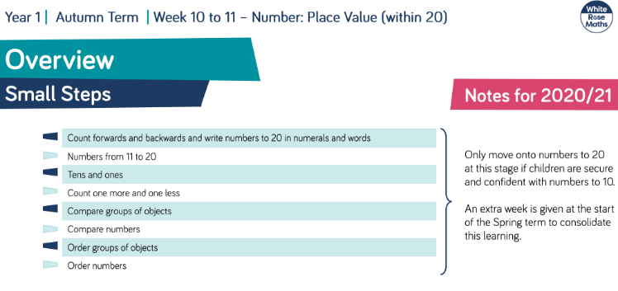
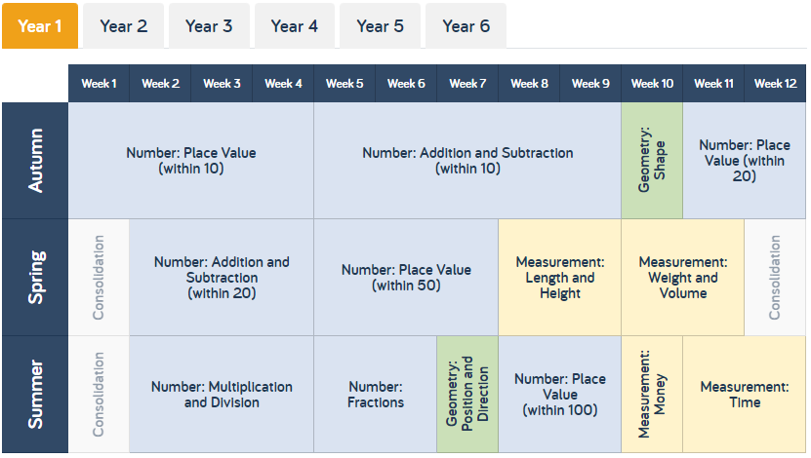

Developing fluency:
We identify in our maths intent statement that we aim to ensure that children are fluent in the fundamentals of the subject. We recognise the importance of this in relation to cognitive overload when working with new concepts. To ensure new concepts are understood, it is vital that children have these fundamentals readily available in their working memory.
Number Sense: To support our aim of developing fluent mathematicians, we have daily Number Sense sessions in years R, 1, 2 & 3 to give pupils a range of strategies to become fluent in addition and subtraction facts, using subitising at the base of it. A key principle of the programme is ‘no more counting’ to solve these facts. Number Sense is then to be used in UKS2 as an intervention where needed.
Times tables: (2022/23 onwards): We use a times table planner for years 3 and 4 to follow to ensure pupil preparedness for the year 4 MTC and to ensure new tables are introduced appropriately, ensuring enough time is given for the table to be taught, understood, consolidated and learnt. Pupils in years 5 and 6 who are not yet fluent in their tables are identified for additional support due to its importance to the UKS2 curriculum. We are to step away from the White Rose small steps for specific tables to allow teachers to spend greater time on other small steps without compromising times table understanding and recall. TT Rockstars supplements this and its aim is to increase speed of recall.
Rapid Recall & Quick Calculations guidance: To support our learners to become fluent mathematicians, a guide has been written to match age appropriate mental maths objectives with the appropriate year group. This ensure teachers are clear on those objectives which they should focus on. Pupils receive regular sessions to develop mental maths skills.
Structure: Pupils receive regular sessions to develop their fluency. These sessions can take place at the beginning of a maths lesson or can take place at a different part of the day. Many classes use early morning time to develop arithmetic skills with ‘flashback four’ or ‘tough ten’ style questions.
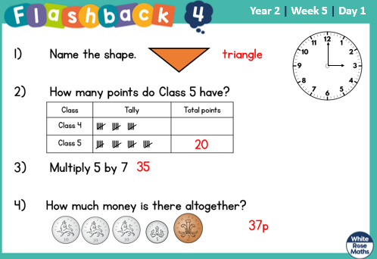
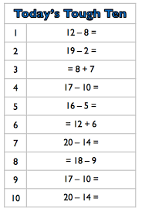

Lesson Structure:
- Lessons often begin with mental oral starters. These can be linked to the upcoming lesson or can be a separate focus, however, these can also be separate stand-alone sessions at a different point in the day.
- Alternatively, lessons may begin with consolidating on previous learning, addressing misconceptions or recapping on arithmetic skills.
- ‘Ping-pong’ style teacher input follows with lots of teacher explanation and questioning, mixed with pupils demonstrating their understanding on whiteboards. Teacher input and explanation is a hugely important part of the lesson and appropriate time is given to this to ensure understanding. The input will also include links to previous learning and a recap on prerequisites which will be needed in the short term-memory to access the lesson. Pre-empting misconceptions and planning for these are a vital part of this stage of the lesson.
- During input, teachers will use a range of different questioning types such as asking pupils to spot the mistake and identify the odd one out before justifying and proving their choices. This can also be seen during independent activities.
- Staff are encouraged to use a range of different resources to suit their learning objective for a specific lesson. We subscribe as a federation to a wide range including: White Rose Premium resources; Classroom Secrets; TT Rockstars; Primary Stars. Staff also create their own resources accordingly or source them from elsewhere to fit the learning of that lesson
- ‘White Rose approach’ means that various representations are consistent across the school and progress from R and Y1 through to year 6 such as bar models and part-part whole models. This consistency supports deepen understanding.
- CPA approach is embedded across the school and appropriate resources are routinely used in all year groups where necessary. Pupils who may find maths slightly more challenging are routinely able to access concrete or visual resources to support them but all pupils can use these resources to deepen their understanding
- We are beginning to develop a ‘mastery’ approach to teaching maths which in its most simplistic term means that ‘all* children progress through the lesson at the same pace and access the same activities’.

