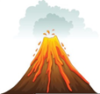
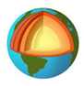
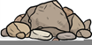

Autumn Term 1
Quest Homework
Year 3/4 - Falcon, Goldfinch and Hawk

Our Quest this half term is called ‘Forces Beneath our Feet’

Throughout this quest, we would love to see some of the wonderful things that you can produce at home. Below, you will find a list of example activities that you may wish to complete and then bring into school, or send to your class email in order to share with everyone. The deadline is the last Monday of the term (20.10.25), as this will give us time to look at everything that has been produced during the final week.

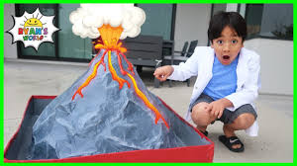
Create a working volcano and bring it in for us to test and enjoy!

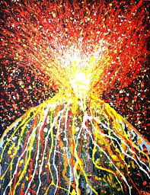

Create a piece of art with the central theme being volcanoes. This could be an oil pastel drawing, a collage, sculpture or textile.

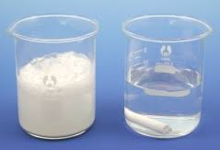
Test how freezing will affect rocks with this simple experiment. Find three different types of rock. Predict which rock will be most affected by freezing. Place them in a plastic container filled with water and freeze for a few days. Remove the container from the freezer and thaw. Repeat these steps several times. Record what happens to each rock after each step by taking measurements, weights and photographs.

